🔹 V8 engine
--------------
Role in Node.js:

Compiles JavaScript into native machine code.

Executes your application’s JavaScript code.

Provides runtime environment for JavaScript features like Promise, async/await, JSON, etc.

Key point:

Think of V8 as the brain of Node.js — it runs your JS code.

🔹 libuv
------------

What it is:

A multi-platform support library focused on asynchronous I/O, Written in C.

Role in Node.js:

Handles the event loop.

Provides non-blocking I/O via thread pool.

Deals with:

File system operations (fs)

Networking (sockets, DNS, HTTP, etc.)

Timers (setTimeout, setInterval)

Child processes

Key point:

Think of libuv as the heart + muscles of Node.js — it powers async operations and event-driven architecture.

⚡ How they work together in Node.js:

# Your JS code runs inside V8.
# When JS calls something like fs.readFile() or setTimeout(), it’s handed off to libuv.
# libuv runs the operation asynchronously (in background threads or via OS).
# When the operation finishes, libuv pushes a callback back into the event loop.
# V8 executes the callback in your JavaScript code.

✅ Analogy

# V8 = The interpreter/engineer → understands and runs JavaScript.

# libuv = The worker manager → handles all async tasks, file I/O, and networking.

# Without V8, Node.js wouldn’t run JavaScript.
# Without libuv, Node.js wouldn’t be asynchronous.

Process, Thread, Thread Pool:
---------------------------------

🔹 1. Process:

A process is an instance of a program running on your system.
Each process has:
Its own memory space (heap, stack, data, code).
At least one thread (usually the main thread).
Example:
If you run node app.js, that starts one Node.js process.

🔹 2. Thread( Single/Main Thread):

A thread is the smallest unit of execution inside a process. OR It's sequence of instractions.

Example:
A browser process may have multiple threads:

# UI thread
# Network thread
# JS execution thread (V8)

🔹 3. Thread Pool
A thread pool is a group of pre-created threads that are reused to perform tasks.
Instead of creating/destroying threads each time (expensive), tasks are queued, and threads pick them up.
Examples of operations that go into libuv’s thread pool:
#File system operations (fs.readFile, fs.writeFile)
#DNS lookups (dns.lookup)
#Compression (zlib, crypto)
#Some networking tasks

🔹 How They Relate in Node.js

#Process: The Node.js instance (node app.js).

#Main thread: Runs your JS code in V8 (single-threaded).

#Thread pool (libuv): Handles async tasks that V8 delegates.

👉 Flow:

#Your JS code (setTimeout, fs.readFile) runs in the main thread.

#Async tasks (like file I/O) go to the libuv thread pool.

#Once done, callbacks are pushed into the event loop.

#The main thread picks them up and executes in V8.

✅ Analogy

#Process = A restaurant.

#Threads = Waiters inside the restaurant.

#Thread pool = A fixed team of waiters that serve tasks (customers) in rotation.

👉 Working Flow of Nodejs Code:
--------------------------------
Initialize programm -> Executes "top-level" code -> require modules -> Registers events callback -> Starts Event loop -> Now event loop offloads heavy
task(Blocking in nature like DB, files operations etc) to Thread Pool to avoid event block and perform asynchronously.

👉 Event Loop:
----------------
JavaScript runs in one thread → it can only do one thing at a time.
If you ask it to read a big file or wait 5 seconds, everything would freeze.
The event loop + libuv solve this by delegating heavy/async tasks away, and only running callbacks when results are ready.

🟢 How It Works (Simplified Steps)

Call stack: Runs your JS code line by line.

If it sees async stuff (setTimeout, fs.readFile), it gives it to libuv.

libuv does the work in the background.

When ready, it puts the callback into a queue.

The event loop checks:

"Is the stack empty?" → Yes → take next callback from the queue → run it.

Repeat forever 🔄

🟢 Example
console.log("A");

setTimeout(() => {
console.log("B");
}, 0);

console.log("C");

👉 Output:
A
C
B

Why?

"A" → runs immediately.

setTimeout → goes to libuv → callback saved for later.

"C" → runs immediately.

Event loop comes back → runs "B".

✅ Event-Driven Architecture of the Event Loop:

When we start a Node.js application, the event loop starts running immediately.
The event loop is responsible for coordinating events, I/O operations, and callback execution.
- 👉 Events are emitted.
- 👉 The event loop picks them up in its current phase.
- 👉 The corresponding callbacks are executed.
🔄 Event Loop Phases:
The Node.js event loop runs in multiple phases. Each phase has its own callback queue:
1. Timers Phase
Executes callbacks from expired timers (setTimeout, setInterval).
setTimeout(() => console.log("Timer expired"), 0);

2. Pending Callbacks Phase
Executes system-level callbacks (e.g., TCP errors).
(less commonly used in app code, so often skipped in explanations)
3. Idle, Prepare Phase
Internal housekeeping for Node.js. (not relevant to user code)
4. Poll Phase ( looking for new i/o event to process and putting them into callback )
- Retrieves new I/O events (networking, file system, etc.).
- Executes their callbacks if ready.
- If nothing is ready, it may block and wait for I/O.
Example:
const fs = require("fs");
fs.readFile("file.txt", () => console.log("File read!"));

5. Check Phase
Executes setImmediate callbacks.
setImmediate(() => console.log("Immediate callback"));
6. Close Callbacks Phase
Executes all 'close' events (like socket.on('close', ...)).

Note: two phases (Pending callbacks, Idle/Prepare) exist but are mostly for internal Node/libuv bookkeeping, not for everyday JS code.

📝 Special Queues (always prioritized before phases):

In addition to the 6 phases above, Node.js has two high-priority queues:
1. process.nextTick() Queue :
• Runs immediately after the current operation, before moving to the next event loop phase.
• Has higher priority than Promises.
console.log("A");
process.nextTick(() => console.log("B - nextTick"));
console.log("C");
// Output: A, C, B – nextTick

2. Microtask Queue (Promises):

Runs after all process.nextTick() callbacks, but still before the event loop moves to the next phase.
console.log("A");
Promise.resolve().then(() => console.log("B - promise"));
console.log("C");
// Output: A, C, B - promise

📌 Together:

console.log("A");

process.nextTick(() => {
console.log("B - nextTick");
});

Promise.resolve().then(() => {
console.log("C - promise");
});

console.log("D");
👉 Output:
A
D
B - nextTick
C - promise

🔑 Summary of Priority
- process.nextTick() (highest async priority)
- Promise microtasks (.then, catch, finally)
- Event loop phases in order:
  - Timers → Pending Callbacks → Poll → Check → Close Callbacks

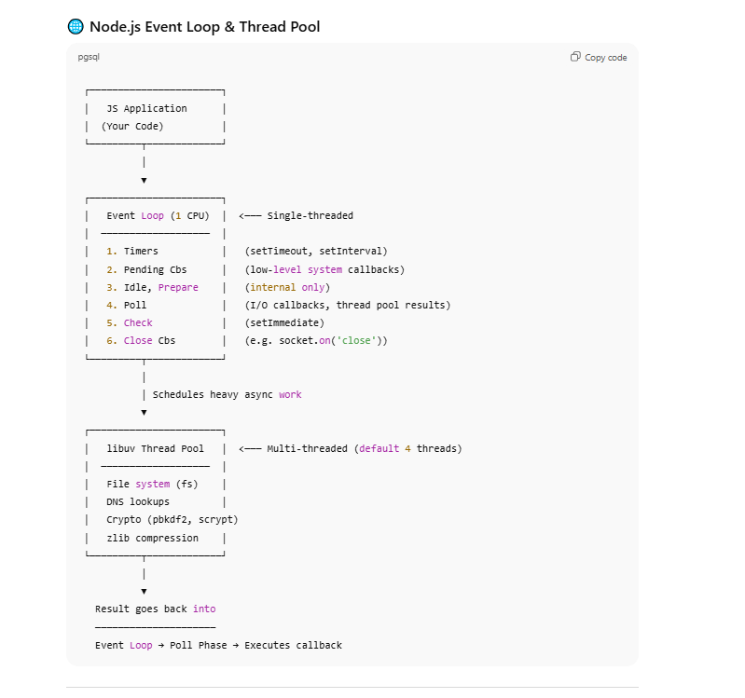
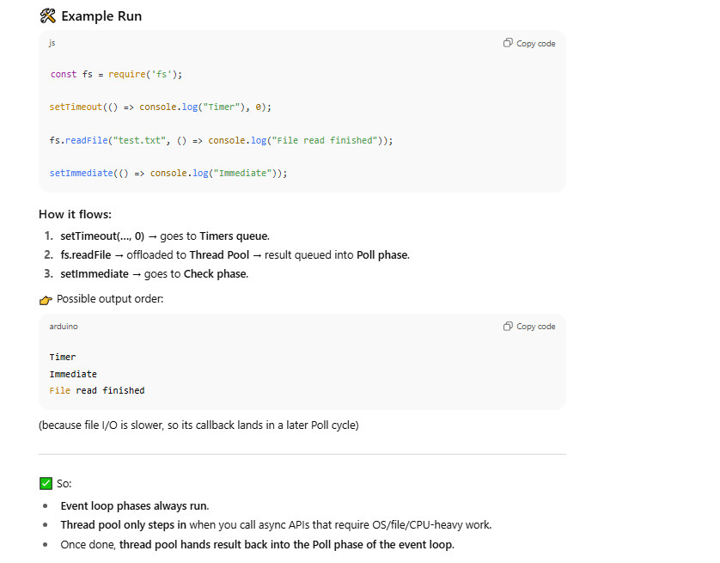
🔹 What are Streams in Node.js?
- Streams are objects that let you read or write data sequentially (piece by piece), instead of loading it all into memory at once.
- Think of it like water flowing through a pipe: you don’t wait for the entire bucket to fill; you can start drinking as it flows.
This is very useful when working with large files, network requests, or real-time data.

🔹 Types of Streams
There are 4 main types in Node.js:
- Readable Stream → You can read data from it (e.g., fs.createReadStream).
- Writable Stream → You can write data to it (e.g., fs.createWriteStream).
- Duplex Stream → Can be both readable and writable (e.g., net.Socket).
- Transform Stream → Duplex stream that modifies/transforms the data as it passes through (e.g., zlib.createGzip).

🔹 Events in Streams
Streams are event-driven. Some common events are:
- data → when a chunk of data is available
- end → when no more data is available
- error → when an error occurs
- finish → when all data is written to a writable stream
🔹 Example 1: Reading a File with Stream
const fs = require("fs");

const readable = fs.createReadStream("bigfile.txt", {
encoding: "utf-8",
highWaterMark: 1024 // read 1KB at a time
});

readable.on("data", (chunk) => {
console.log("Received chunk:", chunk.length);
});

readable.on("end", () => {
console.log("File reading finished");
});
readable.on("error", (err) => {
console.error("Error:", err);
});
👉 Instead of loading the whole file, Node reads chunks (streams of data).
🔹 Example 2: Writing to a File with Stream
const fs = require("fs");
const writable = fs.createWriteStream("output.txt");
writable.write("Hello, ");
writable.write("world!\n");
writable.end("Done writing."); // closes the stream
writable.on("finish", () => {
console.log("All data written successfully!");
});
🔹 Example 3: Piping (Read → Write)
const fs = require("fs");
const readable = fs.createReadStream("input.txt");
const writable = fs.createWriteStream("output.txt");
readable.pipe(writable); // pipes data from read stream to write stream
console.log("Data is being copied via stream...");
👉 pipe() handles backpressure automatically (when writing is slower than reading).
🔹 Example 4: Transform Stream (Compression)
const fs = require("fs");
const zlib = require("zlib");
const readable = fs.createReadStream("input.txt");
const compressed = fs.createWriteStream("input.txt.gz");
readable.pipe(zlib.createGzip()).pipe(compressed);
console.log("File compressed successfully!");

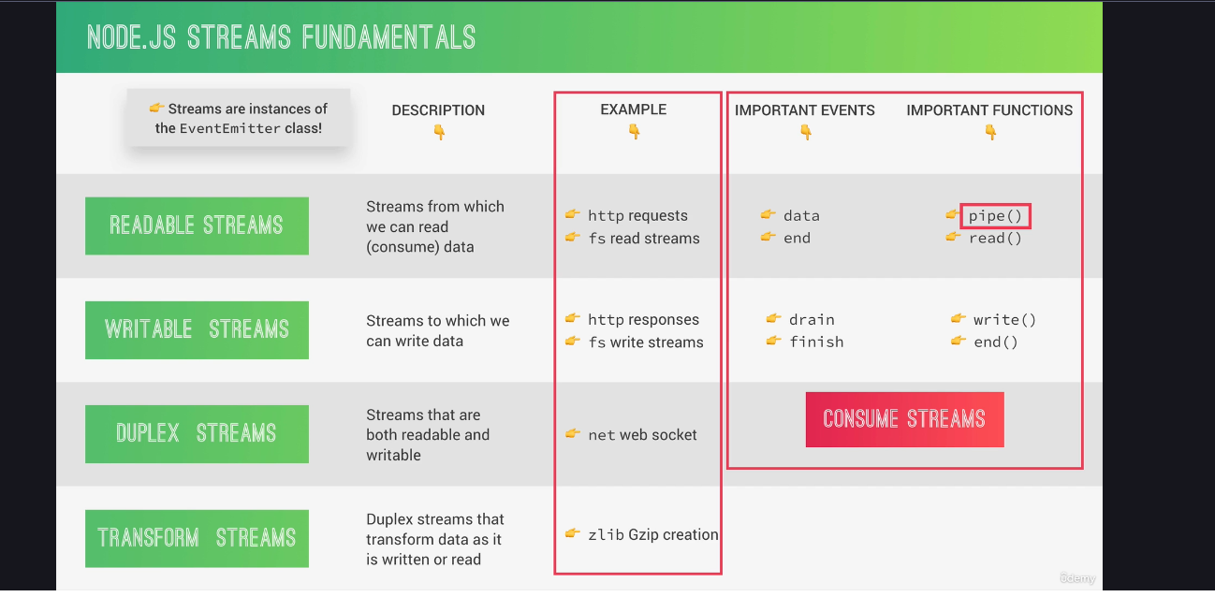

🔹 Real-World Use Cases
- Handling large files (logs, videos, etc.)
- Streaming video/audio to clients
- Sending large HTTP responses without buffering
- Real-time processing (like transforming or filtering data)
- File compression/decompression

SECTION-8

Application Logic:

1. Code that is only concerned about the application’s implementation, not the underlying business problem we’re trying to solve ( e.g: showing and selling tours).

2. concerned about managing request and response.
3. About the app’s more technical aspects.
4. bridge between view and model layers.

Business Logic:

1. code that actually solves the business problem we set out to solve.
2. Directly related to business rules, how the business works, and business needs.
3. Example:
1. creating new tour in the database.
2.checking if user password is correct.
3.validating user input data.

